**Education, science and industry: development and prospects of cooperation within the regional technological platforms**

We invite you to take part in the International scientific and practical Internet-conference called: **“Education, science and industry: development and prospects of cooperation in the framework of regional technology platforms.”**

Location and time of the conference: **Ukraine, Zaporizhzhya,**

**December 1-20.**

* Terms of acceptance of materials – until the November 30 2015.

**Sections of the Conference:**

*Humanities*:

1. History.
2. Jurisprudence.
3. Commercialization of intellectual property registration, evaluation, commercial application.
4. Policy and Legislation in the field of technology transfer.
5. Management.
6. Analysis and adoption of innovative solutions.
7. Innovative management and innovation management.
8. The Economy.
9. Innovation in SMEs (small and medium enterprises).
10. Innovation: issues of commercialization.
11. Commercialization of innovation and international market.
12. Sociology.
13. Engaging students and young scientists to innovate.

*Natural Sciences*:

1. Physical and mathematical sciences and information technology.
2. Atomic and nuclear physics, atomic energy.
3. Theoretical and applied problems of mathematics, physics and mechanics in the context of innovation.
4. Innovative technologies, materials and design.
5. Innovations in the field of Information Technology.
6. Chemistry.
7. Innovative technologies, materials and design.
8. Actual problems of chemistry and technology transfer.
9. Integration of chemical science and industry: through innovation to progress.
10. Biology.
11. Innovative technologies, materials and design.
12. Innovations in the field of biotechnology and human health.
13. Ecology.
14. Innovative technologies, materials and design.
15. General questions of ecology and natural resources.
16. Environmental security areas with different levels of anthropogenic load. Modeling, forecasting, and controls the state of the environment.
17. Environmental Management.

*Technology transfer*:

1. International Instruments Technology Transfer: Systems and Technology Transfer Network.
2. Problems and prospects of technology transfer.
3. The regional technology platforms and their place in the field of innovation.
4. Information technologies and their application in technology transfer.

**Conference languages**: Ukrainian, Russian, English, German, French, Polish.

**The target audience:**

* Management of universities, researchers, teaching staff and students;
* Members of the legislative process on higher education and research;
* Companies that are interested in improving their competitiveness through innovation.

**Conditions of participation:**

1. Fill in and send the application form for participation in the conference and your article drawn up in accordance with extended requirements to: **org_com_ctt@ukr.net.**
2. Wait for the answer of acceptance/non-acceptance of your paper for publication.

Names of submitted documents must comply with the publication of the names of the author, for example - "Shevchenko_Application" and others.

The amount of pages should be 3-5 pages, font Times New Roman, line spacing - 1.5 pt., Size - 14, the field on each side of a sheet - 2 cm.

EXAMPLE

**UDC 12.345:67**

**THERMAL PROCESSES DYNAMICS IN OPERATING ELEMENTS OF BELT DRUM BRAKE OF DRAWWORKS WINCH**

***Ivan Ivanov***

*Candidate of Chemical Sciences, Associate professor of Moscow State University, Moscow*

***Olga Petrova***

*Director of Coordination with Government Agencies, Moscow*

**ABSTRACT**

Background. Methods. Result. Conclusion.

**Keywords:** drawworks winch; molecular-kinetic theory.

Text, text, text……

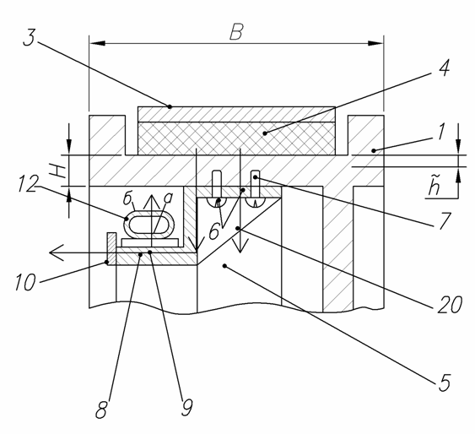

Draw 1. Name

Text, text [1, P 11].

 (1)

where: explanation;

explanation;

explanation;

explanation;

explanation.



***Table 1.***

**Name**

|  |  |  |  |  |
| --- | --- | --- | --- | --- |
| **Text** | **Text** | **Text** | **Text** | **Text** |
| Text | Text | Text | Text | Text |
| Text | Text | Text | Text | Text |
| Text | Text | Text | Text | Text |

Text, Text, Text, Text, Text.

**References:**

1. Nozawa, B. Blankleider. Electroproduction Of Pions On The Nucleon. 2: Polarization Observables /Nozawa S., Blankleider B. и Lee. T.-S.H. // Nucl. Phys. — 1990. — A 513. — 459 p.
2. …